Newsletter articles for parents - prepared by Dakota County Public Health Department

Parents: Be a Role Model for Health

- Audience for this article: parents of pre-school, elementary, middle school, and high school

- 256 words
- Suggested Timing: you may wish to print the article anytime during the school year
- Personalize it for your district:
    - Add any additional information about programs in your school
    - Add any contact information for your district

Parents: Be a Role Model for Health
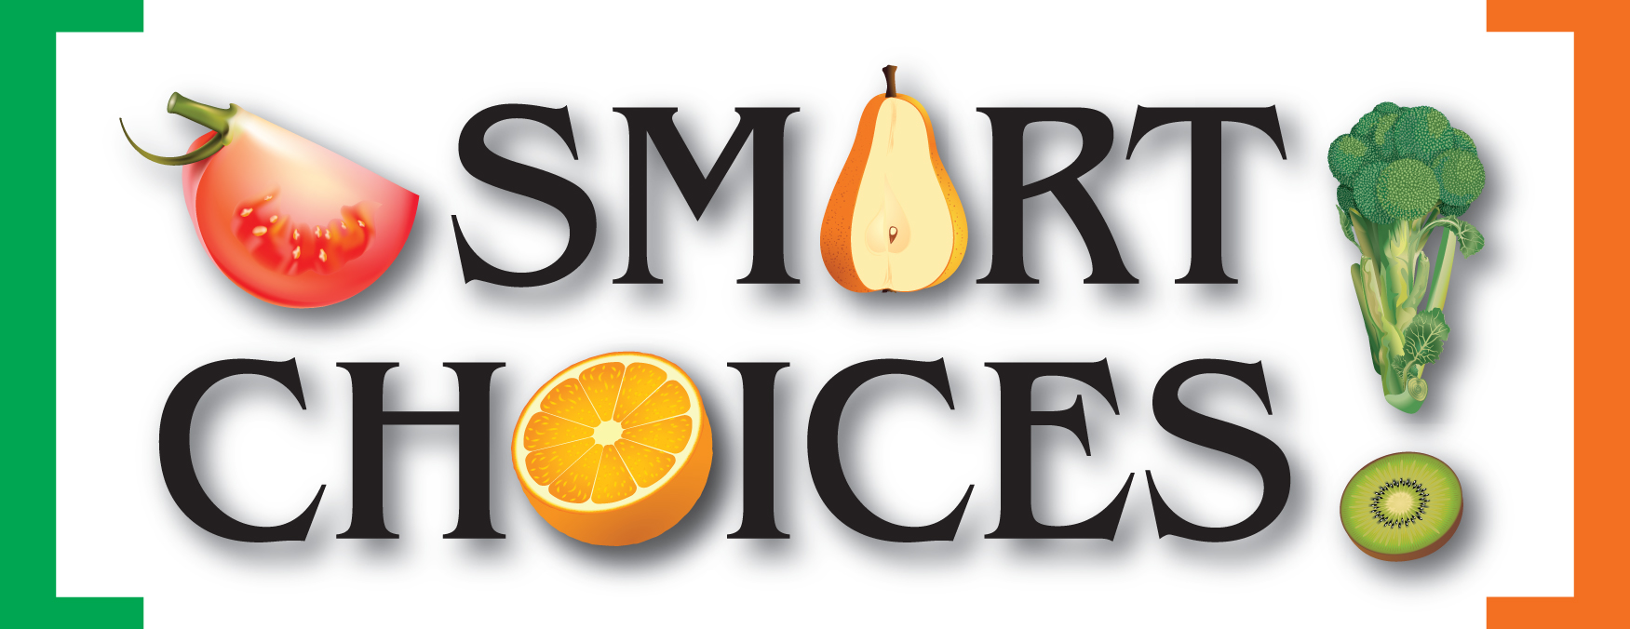
Have you ever told your children to eat their veggies, only to look down at your own plate and realize that you haven’t eaten any yourself? Or does your spouse say “Gross, broccoli!” when you try to serve vegetables? Think about the messages children get when parents don’t follow their own healthy eating advice.

Even when they’re teenagers and are desperately trying to be nothing like you, you are still a role model for your children. They will pay attention to what you say and do and follow suit. Make sure that you are modeling the healthy habits you want your kids to follow:
- Eat breakfast every day.
- Have dinner as a family - at the dinner table, not in front of the TV.
- Eat your fruits and vegetables and drink your milk.
- Focus on healthy foods, not on dieting or “bad” food.
- Limit how often you eat desserts; try fruit after a meal instead.
- If you really don’t like a food, stay quiet about it so your child can form their own opinion.

No one expects you to be a perfect role model; in fact, it can be beneficial to show your children that it is OK to fit a dessert into a balanced diet.

Do your best to model healthy habits - not only are they good for your child’s health, but for yours as well.

For additional information go to:
- http://puttingfamilyfirst.org/
- http://www.healthiergeneration.org/parents

-Information provided by the Dakota County Public Health Department, 11/10

Smart Choices is a partnership of the Dakota County Public Health Department and nine school districts in Dakota County, Minnesota that are committed to making the healthy choice the easy choice.
Funding for Smart Choices is provided by the Minnesota Statewide Health Improvement Program (SHIP) and Blue Cross and Blue Shield of Minnesota through its Prevention Minnesota Initiative.

