CLIENT DRIVEN  SUPPORT  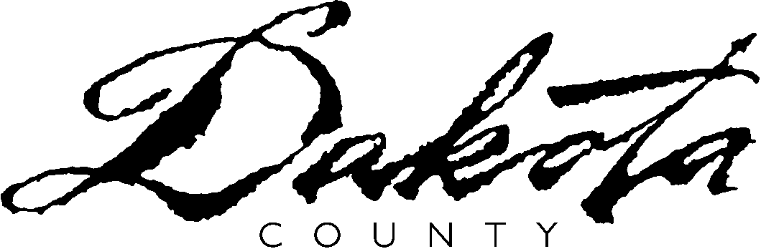 | CLIENT DRIVEN SUPPORT  PARTICIPATION AGREEMENT  CONSUMER SUPPORT GRANT FAMILY SUPPORT GRANT  DAKOTA COUNTY FUNDED CDS  for
 | Client name (please print)

I understand that I will have the authority to spend/direct the funds budgeted by Dakota County for the above named client as I see fit, as long as the expenditures follow the approved Client Driven Support (CDS) Plan and the CDS Policy established by Dakota County and the Minnesota Department of Human Services, as applicable. Dakota County has responsibility for determining the appropriateness of participation in CDS and sole discretion regarding methods for disbursement of funds.

I understand that I am responsible for preparing a CDS Plan and may include whomever I chose to prepare my plan. My Dakota County assigned worker and/or their supervisor, must review and approve the plan before any distribution of funds can occur. If there is a denial of a particular expenditure request, I may ask that a deputy director review the request. If the deputy director denies the request, I understand I have a right to appeal the action taken.

I understand that my approved CDS Plan will be considered the plan in effect, unless and until I discuss changes with my Dakota County assigned worker and the requested changes are approved.

I understand that I am responsible for deciding who will arrange for the supports and services identified in the Plan. I assume full responsibility for my choices of person(s) to provide unlicensed support. I understand they are not Dakota County employees and will not hold Dakota County responsible for any act or omission on the part of this person(s) in provision of that support.

I understand that the persons I select to provide support are mandated reporters of suspected abuse and neglect. As such, by law they are required to report incidents of suspected abuse and neglect of the above named client.

I understand that the amount of funds budgeted for the plan year for the above named client is the sum total of funds available for that plan year. No additional funds are available. If an emergency arises, I can request assistance under regular County procedural guidelines.

I understand I must take part in periodic reviews to assure the effectiveness of the CDS Plan.

I understand that I must submit documentation that substantiates all support and services provided and items purchased. If I misuse funds, I will be required to immediately return the funds. I understand that I must cooperate with any investigation regarding misuse of funds. Falsified documentation will result in county and/or state action.

I have been given a copy of the Client Driven Support Policy and have reviewed it and understand and will comply with its requirements as a condition to remain a participant.

This Participation Agreement and the terms in it continue in effect for the duration of my participation in the program.

Client/Parent/Guardian Signature |  | Date

I have reviewed this agreement with the client and/or their legal representative.
Assigned Worker Signature |  | Date

