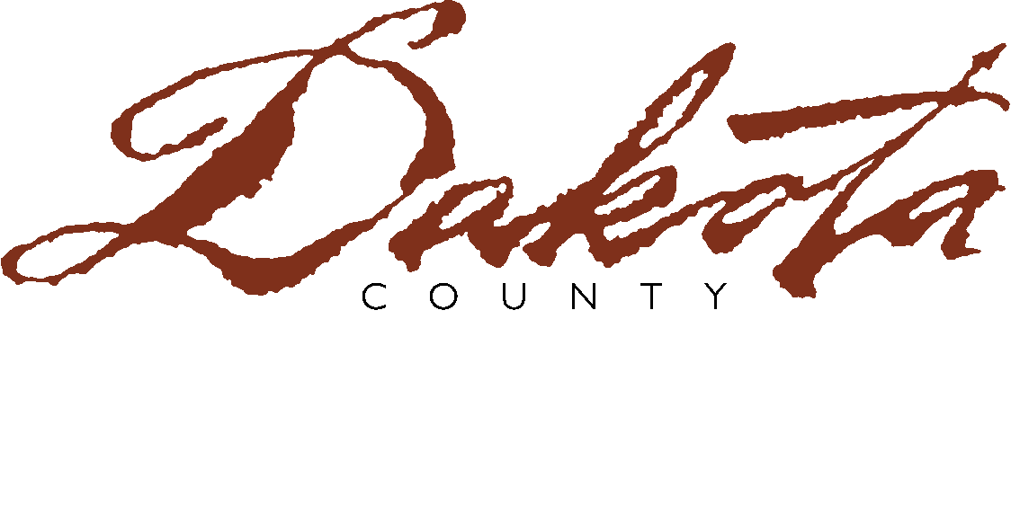
www.co.dakota.mn.us
Western Service Center  14955 Galaxie Avenue  Apple Valley, MN 55124-8579  952.891.7400 • Fax 952.891.7473 | SOCIAL SERVICES DEPARTMENT | Northern Service Center  One Mendota Rd. W., Ste 300  West St. Paul, MN 55118-4770  651.554.6000 • Fax 651.554.6043

FAMILY SUPPORT GRANT PROGRAM

INCOME ELIGIBILITY

Child’s Name

Parent’s Name

County Name

Case Manager Name

Please indicate your annual adjusted gross income as reported on your most recent 1040 tax form:

$

I declare that the above information is accurate to the best of my knowledge. I understand that this information will be used to determine our family’s eligibility for participation in the Family Support Grant Program. If this information is not substantially accurate, payments may be recovered and services may be terminated. I also understand that this information is protected by the Minnesota Data Practices Act.

Parent Signature |  | Date

