July 28, 2026 | EDAK 3017ESW  4/19/07
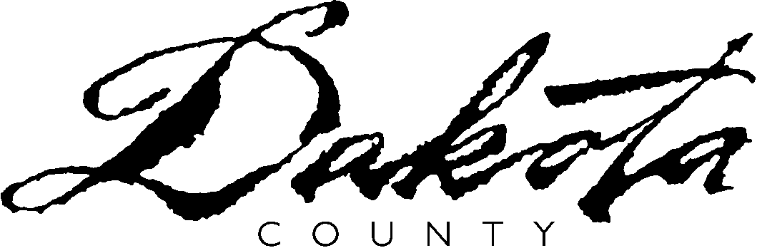 | Agency Name ________________________________  Address ____________________________________  __________________________________________  Phone __________________________________
REQUEST FOR TRAINING

Name:
Name of training program or classes being requested:
Name of school:
Name of occupation or job(s) being trained for:
Training start date: |  |  |  |  |  |  | Training completion date:
I have researched this occupation. I have found there are suitable, full-time job opportunities in the area where I reside.
I have attached documentation for each of the questions below.
List the full-time job leads and source(s) of information you used:
What are the current job opportunities in this field (poor, fair, good excellent)? List the source(s) you used to gather this information:
What is the future job outlook or growth rate for this occupation or job?
What is the school’s placement rate in this program of study? Attach proof of the school placement rate.
The wage for job(s) in this occupation is significantly greater than what I could earn without this training.
The average starting wage of people completing this training and working in this occupation is $ |  |  |  |  |  |  |  |  |  |  |  |  |  |  | .

EMPLOYMENT HISTORY:
List any current or past employers beginning with the most recent.
Employer: |  |  |  |  |  |  |  | Dates Worked: |  |  |  |  |  |  | Hourly Wage:
Describe what you did on this job in a typical day:
Reason for leaving:
Employer: |  |  |  |  |  |  |  | Dates Worked: |  |  |  |  |  |  | Hourly Wage:
Describe what you did on this job in a typical day:
Reason for leaving:
Employer: |  |  |  |  |  |  |  | Dates Worked: |  |  |  |  |  |  | Hourly Wage:
Describe what you did on this job in a typical day:
Reason for leaving:
List any jobs, internships or volunteer experiences and list dates held -
What job related skills do you have?
EDUCATION HISTORY
Circle the last grade you completed and diploma or certificate earned:
1 2 3 4 5 6 7 8 9 10 11 12 GED HS DIPLOMA ESL
Circle the last post-secondary year you completed and diploma or certificate earned:
13 14 15 16 17+ AA Certificate BA/BS
List and describe any training you have received or work related licenses you have (include military related):
Are you currently enrolled in school? |  |  |  |  | Yes No
If yes, name of school:
Type of program:
NOTE: Attach transcripts of all post-secondary training.

RESOURCES TO HELP YOU
COMPLETE YOUR REQUEST FOR TRAINING

Workforce Centers
Northern Service Center
1 Mendota Road West, Suite 100, West St. Paul, MN 55118
(651)554-5667

Western Area
Southcross Commons Center IV
2900 W County Rd 42, Suite 140, Burnsville, MN 55306
(952)895-7600

Dakota County Libraries

Internet Sites
www.iseek.org
Explore Careers/Find Careers/Wages & Jobs and Outlook
www.bls.gov/oco/home.htm
Search the Handbook
www.mncareers.org
Investigate Careers

Books
Minnesota Careers (Workforce Center or Library)
Occupational Outlook Handbook (Workforce Center or Library)

College Career Offices
Dakota County Technical College
(651)423-8301
Inver Hills Community College
(651)450-8500
Normandale Community College
(952)487-8200

