EDAK 3564ESW
2/22/07
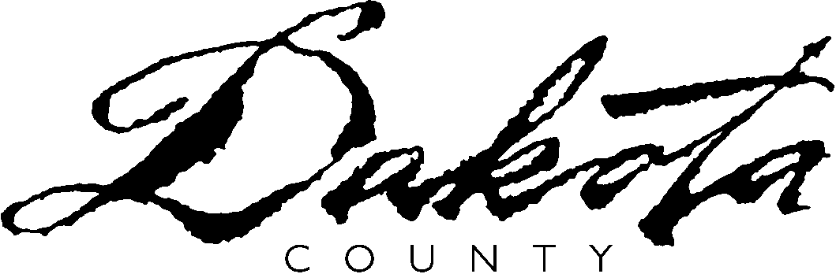

DATE:

TO:

MAXIS #:

Dear

The purpose of this notice is to remind you that your MFIP (Minnesota Family Invest Program) grant is currently in sanction.

This sanction reduces your grant by: 10% 30%

Please call me to learn how you can cure this sanction. After six times of not complying with requirements, your case will close the 7th month. You will need to comply with us for 30 days before you case can re-open. During this time you will not receive a grant from us and will need to re-apply for MFIP.

MFIP has a 60-month time limit. Every month is crucial for you to make a change and become self-sufficient. This sanction will affect your ability to qualify for supportive services funding. It could jeopardize your ability to extend your MFIP past the 60-month time limit.

Sincerely,

Employment Counselor
Phone Number:
Fax Number:

cc: Financial Worker

