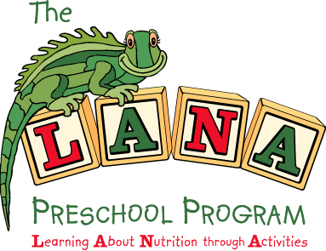

Overview

Welcome to the LANA Preschool Program!

The LANA Preschool Program is a 24-week program promoting preschoolers’ consumption of fruits and vegetables. The program encourages all fruits and vegetables but has a special focus on eight targeted fruits and vegetables*. The targeted fruits and vegetables are featured in activities throughout the program related to three main areas: 1. Menu Changes, 2. Classroom Activities and 3. Family Involvement.

Program Areas | Activities
Menu Changes  To increase opportunities  for children to eat more  fruits and vegetables | - Serve 8 targeted fruits and vegetables on the menu, alternating four one week and four the next week  - Serve fruits and vegetables at snack everyday  - Reduce competitive items on menu when appropriate  - Encourage positive mealtime interactions
- Classroom Activities  To increase children’s  preference for and  knowledge of fruits and  vegetables | - Feature one of the 8 targeted fruits and vegetables each week throughout the program as the “fruit or vegetable of the week”  - Offer weekly tasting and cooking activities in the classroom  - Offer one curriculum theme unit on fruits and vegetables each month during the program. There are activities in all learning areas for each theme unit.
Family Involvement  To give families  information about the  program and activities to  do at home | - Offer three periodic family events  - Provide quick and easy kid-tested recipes using fruits/vegetables  - Provide Parents Talk… About Feeding Kids flyers, addressing day-to-day feeding questions and concerns  - Supply take-home fruit/vegetable tasting kits

*The 8 targeted fruits and vegetables are:
Broccoli Sweet Red Pepper
Cherry tomatoes Apricots
Sugar Snap Peas Kiwi
Sweet Potatoes Strawberries

