July 31, 2026
EDAK 0031A
2/10/14
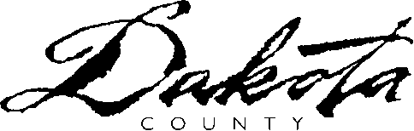 | Employment & Economic Assistance Department  Dakota County Northern Service Center  1 Mendota Road West Suite 100  West St. Paul, Minnesota 55118-4765  Phone 651-554-5611  www.co.dakota.mn.us

Informed Consent

Case Number:

I agree to allow the agency listed below to release the following information

to and with Dakota County Employment and Economic Assistance for the purpose of determining my eligibility for assistance.

Name of Agency:

I know that I do not have to consent to this release of information.
However, if I refuse to consent to this release of information, it is not possible to
process my application. I will not be considered for continued program benefits.

I know that I do not have to consent to this release of information.
I know that my benefits under the program(s) will not be affected by my consent or refusal to release of information.

This consent will be good for one year from the date I sign this form or until it is revoked by me in writing.

Client’s Signature & Date

* Minn. Stat. 15.163, Subd. 4(d)

USDA is an equal opportunity provider and employer.

