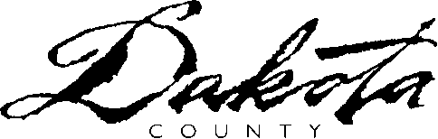 |  | Employment & Economic Assistance Dept.  Dakota County Northern Service Center  1 Mendota Road West Suite 100  West St. Paul, MN 55118-4765  Phone 651-554-5611  www.co.dakota.mn.us
Giving Permission for Someone to Act on My Behalf
To: |  |  | Case Number:
 |  |  | Worker Name:
 |  |  | Worker Phone Number:
 |  |  | Worker Fax Number:
 |  |  | Date: | 7/31/2026

I want to give permission for someone to act on my behalf.

I understand that this person:

- Must be age 18 or older
- May be a friend, a relative, or someone appointed by the court. This person must be able to provide complete and accurate information
- Can help me fill out forms and provide information. This person would need to inform the agency within ten days of any changes related to eligibility (income, property, marital status, etc.)
- Will act for me until I no longer want him/her to. I will notify my worker when I want this to end.

I am giving permission to |  | to act for me.
(Print the name of person acting on your behalf)

Check this box if you want this person acting on your behalf to receive all correspondence.

YOUR NAME (PRINT) | YOUR SIGNATURE: |  | DATE:
YOUR STREET ADDRESS | CITY | ZIP | PHONE  ( )
SIGNATURE OF PERSON ACTING ON YOUR BEHALF |  |  | DATE:
HIS/HER STREET ADDRESS | CITY | ZIP | PHONE

If you have any questions, call your worker.

USDA is an equal opportunity provider and employer.

