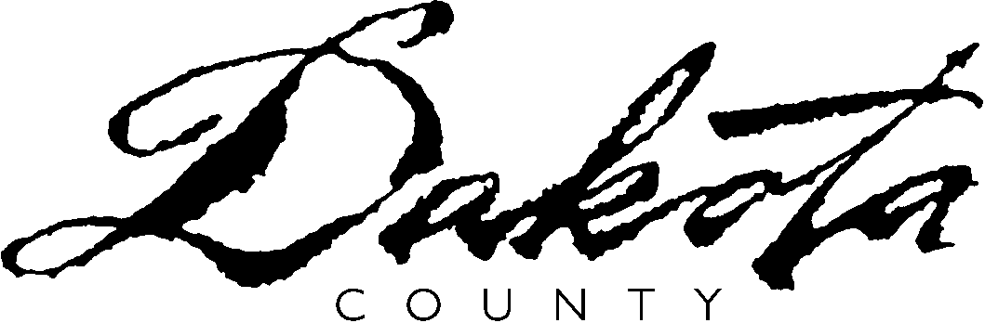

Solid Waste Facility License Renewal/Modification Application

Application is for (check appropriately): License Renewal License Modification

The undersigned applicant(s), in accordance with Dakota County Ordinance No. 110, Solid Waste Management, hereby applies to Dakota County for the renewal or modification of a license to operate a solid waste facility known as ________________________________ during calendar years _____________________.

I have attached all information regarding any changes to the planning, construction, development, operation, financial assurance, and closure of the facility since the last such disclosure was made and approved.

Certification. I certify under penalty of law that I have personally examined and am familiar with the information submitted in this and all attached documents, and that based on my inquiry of those individuals immediately responsible for obtaining the information, I believe that the submitted information is true, accurate and complete. I am aware that there are penalties for submitting false information, including the possibility of a fine and imprisonment.

I further certify that the above-named facility will be operated in a manner consistent with the approved plans, specifications and documents attendant to this application and on file in the office of the Dakota County Environmental Management Department. The facility shall comply with: (1) all applicable laws, statutes, rules and ordinances; (2) the conditions of any other required licenses or permits; and (3) all conditions imposed by the Dakota County Board of Commissioners and/or the Dakota County Environmental Management Department. I understand that penalties may be imposed for the facility’s failure to comply with any of the aforementioned requirements, including, but not limited to the suspension and/or revocation of the license.

Licensee: ___________________________________________________________________
(Pursuant to Dakota County Ordinance No. 110, Section 3.02 (D), the Facility Operator is the Licensee.)

Responsible Person: ___________________ Title: ______________________________

Phone: _______________________________ Email: _____________________________

Signature: ____________________________ Date: _____________________________

Pursuant to Ordinance No. 110, Section 3.02 (D), a Co-Licensee may be required or requested:

Applicant requests Co-Licensee(s) as listed below
Department requires Co-Licensee(s) as listed below

Co-Licensee (1): ______________________________________________________________

Responsible Person: ___________________ Title: ______________________________

Phone: _______________________________ Email: _____________________________

Signature: ____________________________ Date: _____________________________

Co-Licensee (2): _____________________________________________________________

Responsible Person: ___________________ Title:______________________________

Phone: ________________________________ Email:_____________________________

Signature: ____________________________ Date: _____________________________

Solid Waste Facility License Renewal/Modification Application

FACILITY NAME:_____________________________________

FACILITY TYPE:_____________________________________

FACILITY ADDRESS:_________________________________

Is this a MULTIPLE OPERATION FACILITY? Yes ____ No ____
If Yes, a separate form must be completed for each operation.

Sections A and B must be completed for every type of facility.

For a LAND DISPOSAL FACILITY (sanitary, demolition, special waste, and special waste storage), also complete Section C.

For a TRANSFER STATION, PROCESSING FACILITY, COMPOSTING FACILITY, or OTHER FACILITY, also complete Section D.

Section A - WASTE TYPES AND QUANTITIES

Indicate the approximate percentage of each waste type that the facility accepts.

MSW ______________%
-Residential ______________%
-Commercial ______________%

Industrial ______________%

Construction ______________%

Demolition ______________%

Source-Separated Compostable Materials ________%

Source-Separated Recyclables ______________%

Yard Waste ______________%

Wood Waste ______________%

Other(describe) ______________________________ ______________%

Other(describe) ______________________________ ______________%

Section B - FINANCIAL ASSURANCE

Are you requesting any changes to your current financial assurance? Yes ____ No____
If Yes, please attach information describing the requested change.

1b. Pre-Closure/Operational Financial Assurance

Irrevocable Letter of Credit $________________

Account or Document No.:_________________
Expiration Date: _________________
Date of Origin: _________________
Notification Period For Cancellation: _______days

Surety Bond $________________

Account or Document No.:_________________
Expiration Date: _________________
Date of Origin: _________________
Notification Period For Cancellation: _______days

Single Access Cash Account $________________

Account or Document No.:_________________
Expiration Date: _________________
Date of Origin: _________________
Notification Period For Cancellation: _______days

2b. Closure Plans Financial Assurance (Post Closure Information For Land Disposal Facilities Only)

CLOSURE POST-CLOSURE
Current Amount Current Amount

Irrevocable Letter of Credit $________________ $__________
Account or Document No.: _________________ ___________
Expiration Date: _________________ ___________
Date of Origin: _________________ ___________
Notification Period For Cancellation: _______days ___________days
Single Access Cash Account $________________ $__________
Account or Document No.: _________________ ___________
Expiration Date: _________________ ___________
Date of Origin: _________________ ___________
Notification Period For Cancellation: _______days ___________days

Trust $________________ $__________
Account or Document No.: _________________ ___________
Expiration Date: _________________ ___________
Date of Origin: _________________ ___________
Notification Period For Cancellation: _______days ___________days

MPCA Financial Assurance Plan $_______________ $__________
Account or Document No.: _________________ ___________
Expiration Date: _________________ ___________
Date of Origin: _________________ ___________
Notification Period For Cancellation: _______days ___________days

Other: _____________________ $_______________ $_______________
Account or Document No.: _________________ ___________
Expiration Date: _________________ ___________
Date of Origin: _________________ ___________
Notification Period For Cancellation: _______days ___________days

- Provide copies of the existing financial assurance documents.

3b. Insurance

Amount Expiration Date

General liability $____________ _____________
Automobile liability $____________ _____________
Workers compensation $____________ _____________

- Provide copies of the existing insurance documents.

Section C - LAND DISPOSAL FACILITIES

1c. Are you requesting a modification to previously submitted operational plans and/or facility specifications? Yes ___ No ___ If yes, please attach an explanation of the modification.

2c. Are you requesting a modification to previously submitted Closure Plans? Yes ___ No ___ If yes, please attach an explanation of the modification.

3c. Current in-place volume:________________________(cubic yards)

4c. Total acreage of the waste disposal area: _______________________

____ acres of the site are currently an active fill area.

____ acres of the site have been previously filled but have not reached final elevation.

____ acres of the site have reached final elevation.

____ acres of the site that have reached final elevation and have received
intermediate cover.

____ acres of the site have reached final elevation and have received final cover
according to Dakota County Ordinance No. 110 and MN Rule,
Chapter 7035.

5c. What is the total permitted capacity of the facility?

(cubic yards) ________________________________________

6c. What is the remaining capacity of the facility?

(cubic yards) ________________________ As of (date) __________

7c. What is the projected life span of the facility? _________years_______months

Based on an infill rate of: _______________tons of waste per month.

Section D - TRANSFER STATIONS, PROCESSING FACILITIES, COMPOSTING FACILITIES, & OTHER FACILITIES

1d. Are you requesting a modification to previously submitted operational plans and/or facility specifications? Yes ___ No ___ If yes, please attach an explanation of the modification.

2d. Are you requesting a modification to previously submitted Closure Plans? Yes ___ No ___ If yes, please attach an explanation of the modification.

3d. Current licensed throughput capacity of the facility: _________________________
Are you requesting a modification to the current licensed throughput capacity of the facility? Yes ___ No ___
If Yes, attach an explanation of the requested change.

4d. Current licensed storage capacity of unprocessed waste at the facility: Indoors:_____________Outdoors:____________

Are you requesting a modification to the current licensed storage capacity of unprocessed waste at the facility? Yes ___ No ___
If Yes, attach an explanation of the requested change.

5d. Current licensed storage capacity of processed material:
Indoors:________________ Outdoors:__________________

Are you requesting a modification to the current licensed storage capacity of processed material at the facility? Yes ___ No ___
If Yes, attach an explanation of the requested change.

