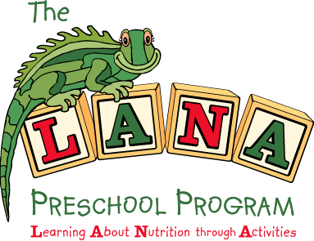

Tips for Positive Mealtime Interactions

Encourage through words:
- Encourage children to taste a variety of foods
- Praise and reinforce children for trying and tasting f/v
- Understand consequences of bribing, forcing or rewarding children
    - Rewards can backfire – devalue vegetable and increase value of the reward
    - Nagging or cajoling can increase resistance to new or desired food
- Identify and emphasize fruit and vegetable choices at meals

Encourage through behavior:
- Model positive eating habits (eating f/v)
  - Actions speak louder than words – children are aware of what adults do and say
  - A positive role model can help a child overcome their hesitation to try foods
- Eat meals and snacks with children
- Serve/offer age appropriate portions to children
- Understand “normal” childhood eating behaviors
  - Expect food waste
  - Irregular eating habits
  - Expect spills and a mess
  - There will be squirming
- Involve children in meal preparation (age appropriate tasks)

Encourage through the environment:
- Offer f/v every day at breakfast, lunch and snack
- Substitute or reduce availability of foods that compete with f/v
- Offer repeated opportunities for children to try new f/v
- Create a calm and supportive meal time environment
  - Reduce distractions during meals
    - No T.V. or videos during meals
    - No distracting loud/active music
  - Create regular, structured mealtime routines
  - Promote positive conversation at meals
  - Encourage and allow children to eat at their own pace
  - Promote good table manners
- Encourage children to serve themselves and regulate their own food intake

Division of Responsibility for Feeding Children

Adults are responsible for: Children are responsible for:
*What food is offered *How much food is eaten
*When food is offered *Whether they eat
*Where food is offered

